**VIMIGO UI UX Developer Assessment**

Option 2: **Leaderboard**

Design the UI/UX of a leaderboard module within a company app.

A real estate firm has developed an app to track, measure, and reward it's employees based on their sales performance. The Company has tasked you to design a leaderboard module for their app. The app is intended to be viewed mainly by the employees who are out making sales. It is meant to show them how they are placing amongst their peers and to encourage them to be better. Leaderboards are not fixed and the employee should be able to select how they want to be ranked based on:

■ **Timeframe** - to see their ranking for today, for the week, for the month, or for the year.

■ **Region** - to see their ranking in a selected suburb or a whole state

■ **metrics** - to see their ranking based on total sales $, number of apartments sold, number

of houses sold, number of units rented. and any other metric you can think of.

* Candidate Name: Lee Kai Yang
* Education: University of Malaya
* Position applied: Internship UI UX Web Developer in VIMIGO
* Software Used: Adobe Xd Application
* Art board Used: iPhone X-XS-11 Pro
* Product: UI UX of a leader board module of real estate firm

**Dark mode UI Design of Leader board**

- Background colour chosen is purple grey and font colour white to create contrast.

- Employee can click ‘Left arrow’ to go back to previous page.

- Reload button, search button and vertical ellipsis (three dots) are placed on right top of page.

- 3 Functional Filters: 1st Timeframe, 2nd Region & 3rd Metrics.

- Timeframe Button List allows employees to select the leader board result for different timeframe: Today, Week, Month, Year and All Time.

- Purple line on top indicates which timeframe employees selected.

- ‘How it Works’ allows employees to know how the system algorithm works and how they are being evaluated. Employees can click in for more details.

- Top 3 employees are displayed on larger space and followed by 4th, 5th and so on to show employees how they are placing amongst their peers and to encourage them to be better.

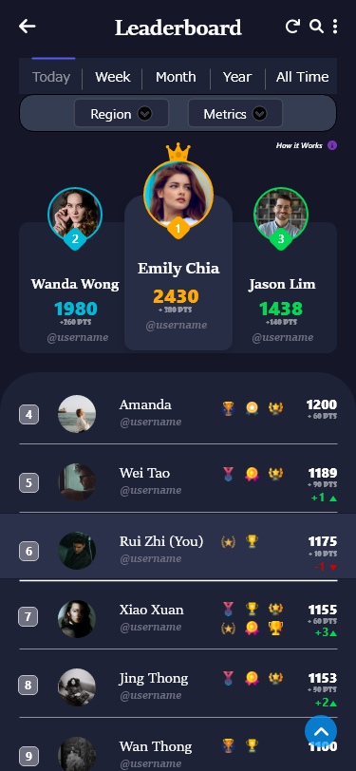

**Overview - Dark Mode UI Design**

**Region Button**

Region Dropdown List allows employees to select different regions: selected suburb / a whole state to filters out the leader board results.

The background of Region Dropdown List changes to darker and down icon changes to white colour when the employee hover and clicks on it to show hover effect.

The leader board ranking outputs different results based on what employee select.

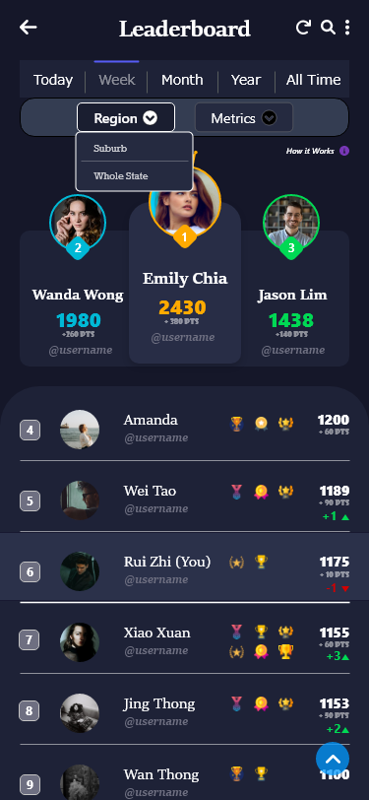

**Region Button**

**Metrics Button**

Metrics Dropdown List allows employees to select different metrics: Total Sales (in RM), number of apartments sold, number of houses sold and number of units rented.

The background of Metrics Dropdown List changes to darker and down icon changes to white colour when the employee hover and clicks on it to show hover effect.

The leader board ranking outputs different results based on what employee select.

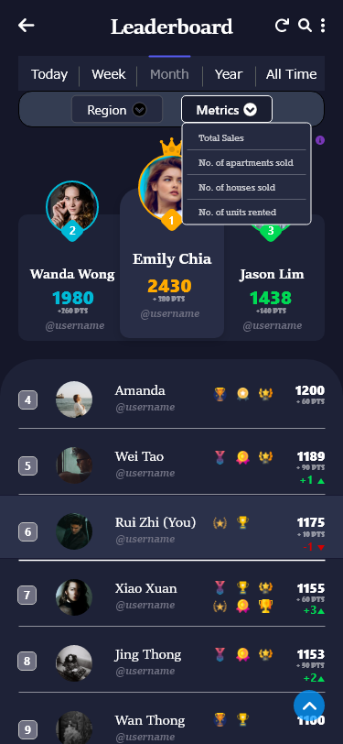

**Metrics Button**

**Region-Suburb + Metrics-Total Sales**

- Example, Timeframe selected is ‘**Week’**, Region selected is ‘**Suburb’** and Metric selected is ‘**Total Sales**’. The leader board ranking outputs different results.

- Profile picture, employee name, username, **total sales in the week** and **number of sales increased** are displayed.

- Numbers of ranking UP or DROP is also available. Green indicates higher ranking compared with last week while red indicates lower ranking compared with last week.

- Past award or badges claimed by employees are shown on the same row.

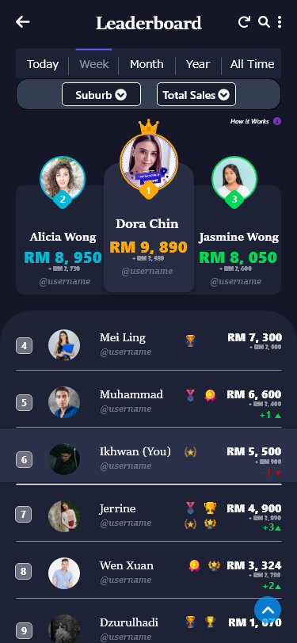

**Region-Suburb + Metrics-Total Sales**

**Region-Whole State + Metrics- Units Rented**

- Example, Timeframe selected is ‘**Week’**, Region selected is ‘**Whole State**’ and Metric selected is ‘**Units Rented’**. The leader board ranking outputs different results.

- Profile picture, employee name, username, **units rented in the week** and **number of units rented increased** are displayed.

- Numbers of ranking UP or DROP is also available. Green indicates higher ranking compared with last week while red indicates lower ranking compared with last week.

- Past award or badges claimed by employees are shown on the same row.

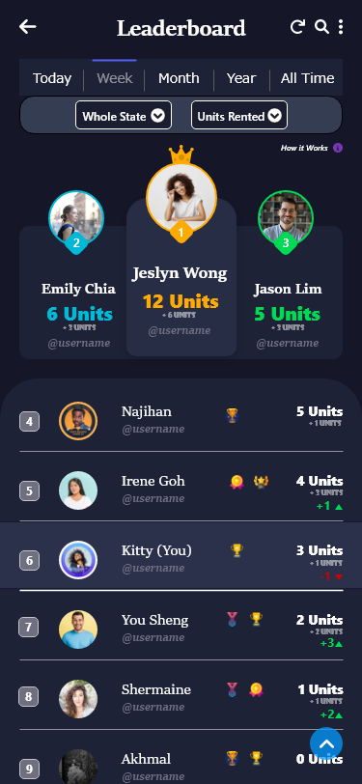

**Region-Whole State + Metrics- Units Rented**